***Lab 11-Internationalization***

*Create a new MVC Application:*

*File > New > Project > Project Name: “Lab 11-Internationalization” > MVC > OK*

*Right click on Model folder > Add > Class > Name the class as Person.cs > Add the following code:*

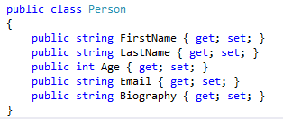

*Now we shall add the resources to change the content of the website. Add Main Resource File:*

*Right click on the project > add > New folder >rename it to LocalResource > Right click LocalResource folder > Add > New Item > Resources File > Name it as Resource.resx > click on Add button*

*In the same Way add more 4 resource files:*

* *For the English you can add "Resource.en-GB.resx".*
* *For Marathi you can add "Resource.mr-IN.resx".*
* *For Hindi you can add "Resource.hi-IN.resx".*
* *For Arabic you can add "Resource.ar-SA.resx".*
* *For French you can add “Resource.fr-FR.resx”*

**Note: The Resource name has as the Language codes suggested by Microsoft:** [**https://msdn.microsoft.com/en-us/library/ms533052(v=vs.85).aspx**](https://msdn.microsoft.com/en-us/library/ms533052(v=vs.85).aspx)

*Open Resource.resx > Add resource name under name column > change the access modifier to Public.­*

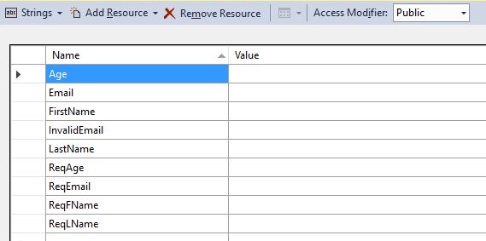

*Open "Resource.en-GB.resx" and perform the following:*

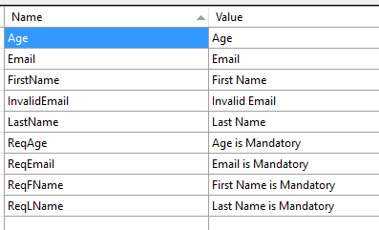

*Open Resource.hi-IN.resx and perform the following:*

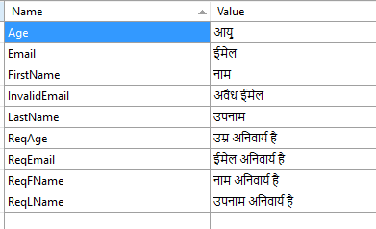

*Open "Resource.mr-IN.resx" and perform the following:*

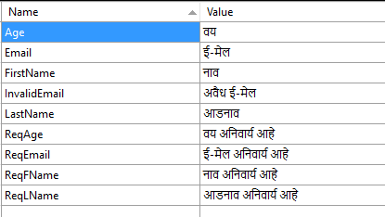

*Open "Resource.ar-SA.resx" and perform the following:*

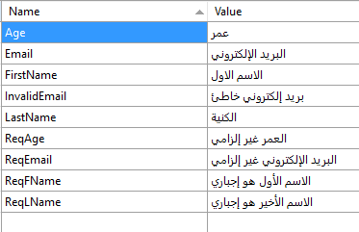

*Open "Resource.fr-FR.resx" and perform the following:*

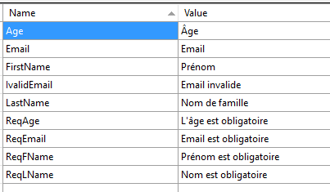

*Now we make the following changes in the Person.cs*

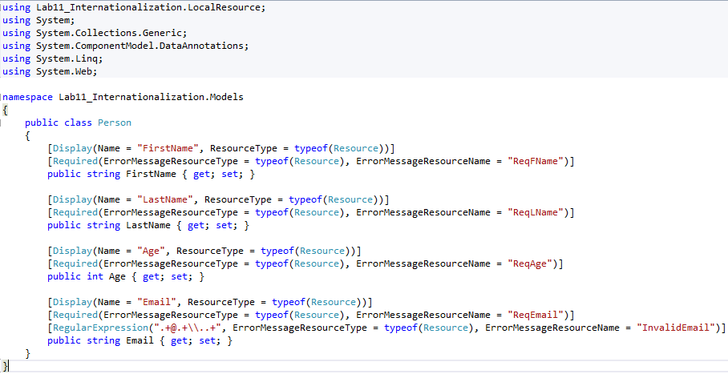

*Right click on the project > add > New folder >rename it to Helpers > Right click Helpers folder > Add > Class > CultureHelper.cs and write the code*

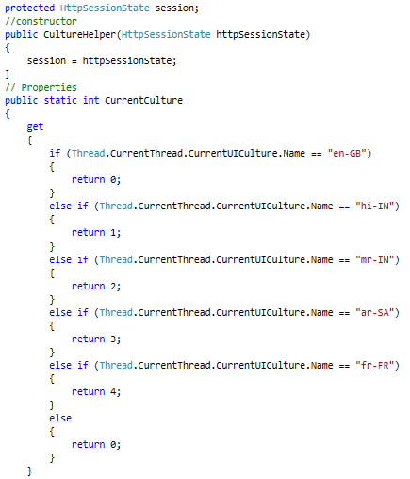

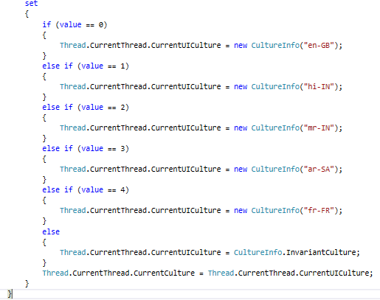

*Right Click on Controller folder > Add > Controller > Select MVC Controller > Add > Enter controller name = “BaseController”*

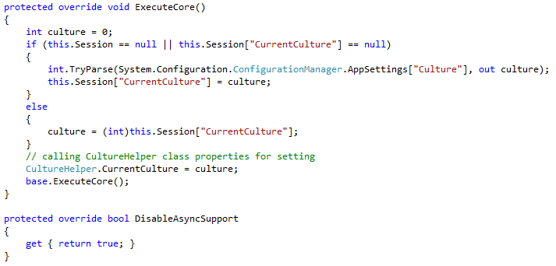

*Right Click on Controller folder > Add > Controller > select MVC 5 controller with read/write actions > Add > Enter controller name = PersonController*

*Inherit BaseController in PersonController and add the following code:*

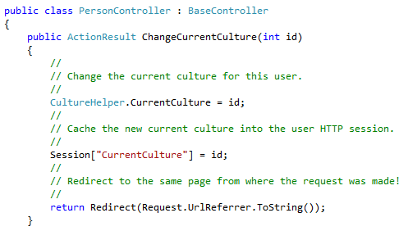

*Build the project*

*Right click on Create Action method and add view*

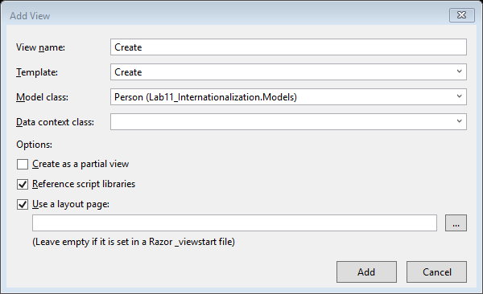

*After the view is added. Go to _Layout.cshtml page and comment the following code:*

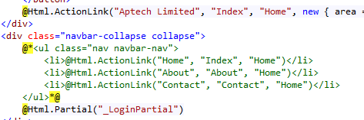

*Go to _LoginPartial.cshtml page and add the following code:*

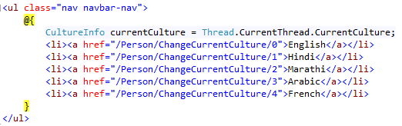

*Go to RouteConfig.cs and make the following changes:*

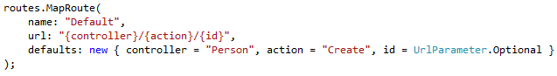

*Now execute the project:*

